**Decomposition**

Object-oriented decomposition, on the other hand, breaks a large system down into progressively smaller classes or objects that are responsible for some part of the problem domain.

In this example we have want to write an interpreter that perform a single sum operations.

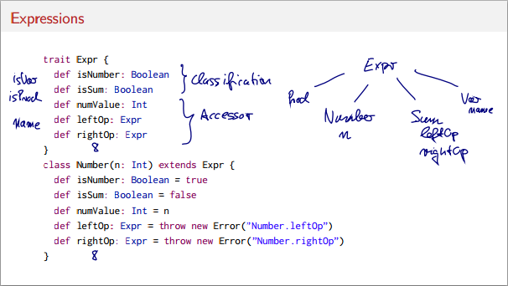

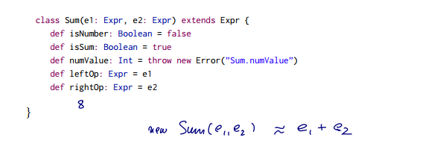

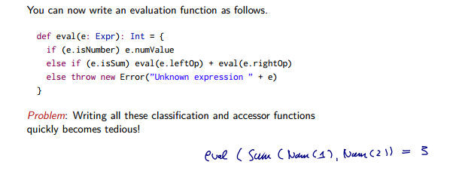

We cannot write a **classification per class type** every time a new sub class of Expr is created.

